Project Framework

Problem Statement

* **Problem**:
* Many people are posting reviews about products and services online with false information
* **Objective**:
* Develop a successful machine learning model using sentiment analysis and nlp techniques to detect the difference between an authentic and an inauthentic online review with a reasonable level of accuracy
* **Research Question:**
* How can existing analytical methods be improved on to alert customers about inauthentic reviews online and filter them out so that more genuine information is available for products and services.

In this study, the concept of ‘improving existing analytical methods’ is the focus. A detailed literature review has been conducted by consulting a wide range of sources to provide a comprehensive overview of the existing analytical methods available.

According to [recent statistics](https://www.forbes.com/sites/ryanerskine/2017/09/19/20-online-reputation-statistics-that-every-business-owner-needs-to-know/#e8e96bdcc5c9) ( source; [Fake Online Reviews: Unethical, Illegal and Bad for Business (digitalexaminer.com)](https://www.digitalexaminer.com/just-say-no-fake-online-reviews/))

* 90 percent of consumers read online reviews before visiting a business.
* Online reviews impact 67.7% of purchasing decisions.
* 74 percent of consumers say positive reviews increase their trust in local businesses.

Inauthentic’ reviews exist online. Customers depend on genuine reviews to inform them for quality and economic and safety purposes.  These nuggets of wisdom and caution aim to bridge information and issues between buyers and sellers, or buyers and other buyers by providing information that may not be otherwise disclosed. Businesses are paying to have more positive reviews about them online to increase sales and hotel stays to increase their profits. Other reviews have been created by consumers who have been financially incentivised.  Dubious performing businesses can damage the reputation of a platform for other transparent businesses. They tend to also generate revenue for that business which wouldn’t otherwise have been generated which raises ethical and legal concerns.

Inauthentic reviews can lead to financial and safety risks for consumers as they may end up buying low-quality products or services or worse, be at risk of scams or fraud.

**Methodology**

Based on the existing knowledge about what flags are used to currently detect authentic and inauthentic reviews, rule-based classifiers have been chosen to detect and filter out some of the more obvious candidates.

The rules used in this thesis have been generated based on existing knowledge of flagging reviews, whether the fault is from the business itself or one user. The rules will be ordered based on their weighting; some red flags carry more weight than others.

Some of the red flags from a user include numerous reviews on one or multiple platforms, an excessive amount of punctuation, the frequency of certain words and a lack of specific detail. Some red flags for businesses include a large amount of extremely positive or negative reviews and a non-normal distribution of ratings. The rules will not be mutually exclusive. Based on multiple check’s, a traffic light system and a quantitative result will be given on the likelihood of the review being inauthentic which can be visualised. The rules may not be exhaustive, therefore if none of the rules are exhausted by a review, it will be assigned a default class.

The text cleaning was completed as part of preparation for these rules. The number of stop words, the types of punctuation symbols, syntactic and lexical category quantities etc adds valuable information about each review and contributes to its correct classification. positive speech tagging (POS) for nouns, adjectives was completed with Averaged Perceptron Tagger as part of the Textblob package.

Sentiment Analysis was completed with Vadar Sentiment package.

The library spaCy was employed for tokenisation, text classification and named entity recognition

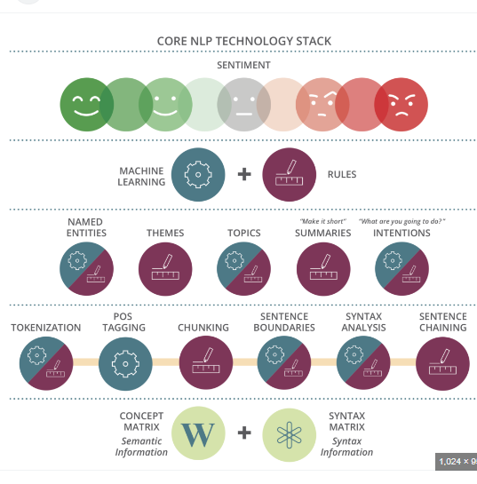

**Literature review**

* Tbd

Ethical Concerns

[Fake Online Reviews: Unethical, Illegal and Bad for Business (digitalexaminer.com)](https://www.digitalexaminer.com/just-say-no-fake-online-reviews/)

Engaging in inauthentic reviews is unethical at best and illegal at worst. In addition to financial and safety concerns, inauthentic reviews pose ethical and legal issues. Businesses create their own ecosystem of fake review practices, such as paying for positive reviews or incentivizing consumers to leave reviews, are engaging in dishonest and manipulative behaviour that undermines the credibility of the review system. Furthermore, the presence of inauthentic reviews on a platform can harm the reputation of the platform and legitimate businesses that operate on it. Consumers may lose trust in the platform, leading to reduced traffic and revenue for both the platform and honest businesses. This can lead to a vicious cycle in which legitimate businesses are forced to compete with fake reviews to maintain their visibility, further eroding trust in the review system and the platform as a whole. Such practices also unfairly advantage some businesses over others, leading to an uneven playing field in the marketplace